List of Students who completed internship in Industry/Institute (2021-22)
Name of Student | College Roll No. | Class | Internship Details
Kamini | 25103 | M. Sc. Part-II | Selected in Molecular NGS department of CORE Diagnostics, Gurgaon for six-month research project/Internship.  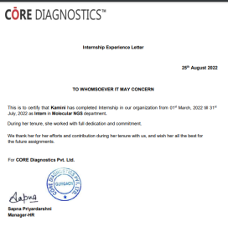
Rakhi | 25104 | M. Sc. Part-II | Selected in Molecular NGS department of CORE Diagnostics, Gurgaon for six-month research project/Internship.  